**Assignment 2  
Create Epic**

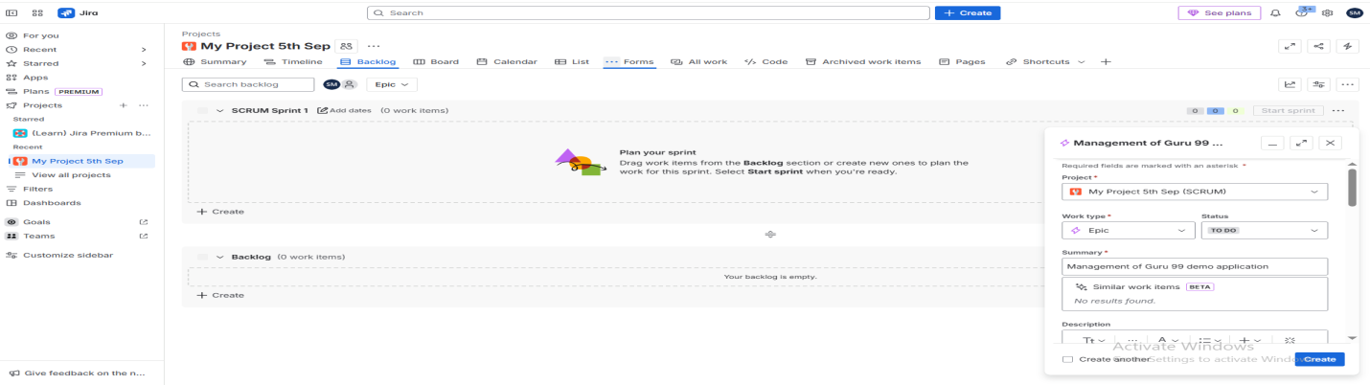

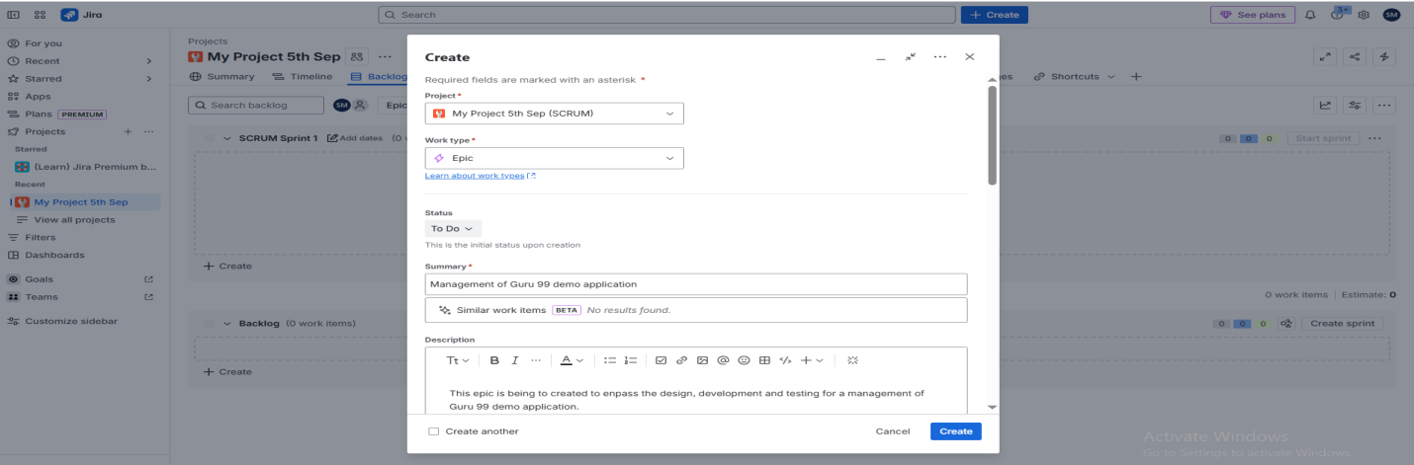

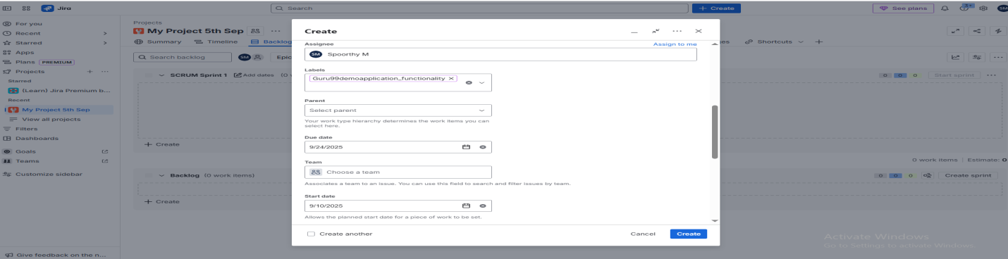

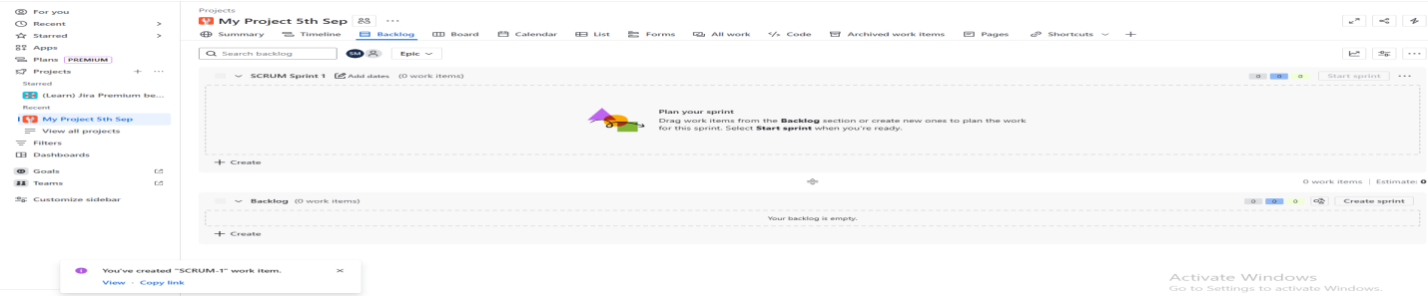

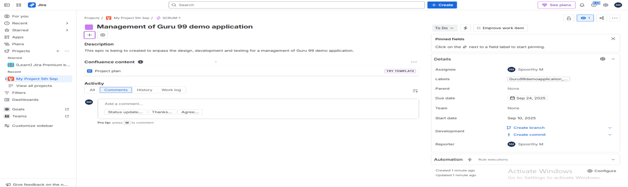  
**Create User Story   
Login –** Design and Architecture of login

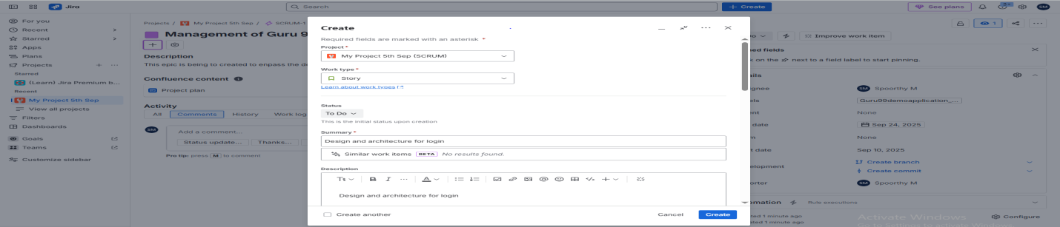

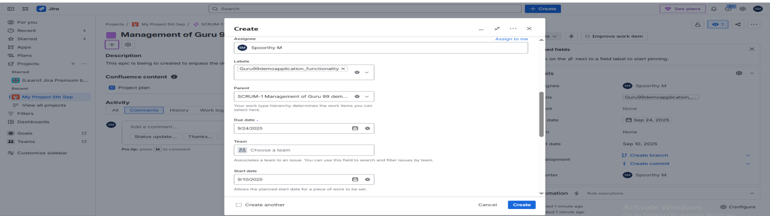

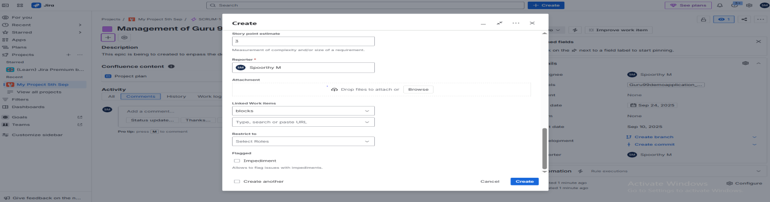

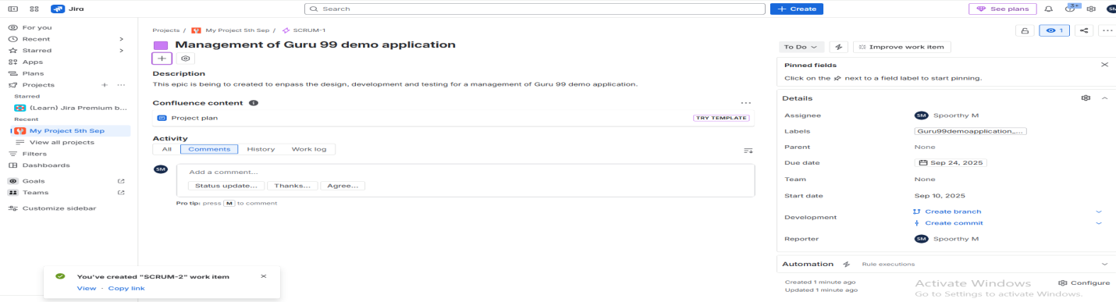  
**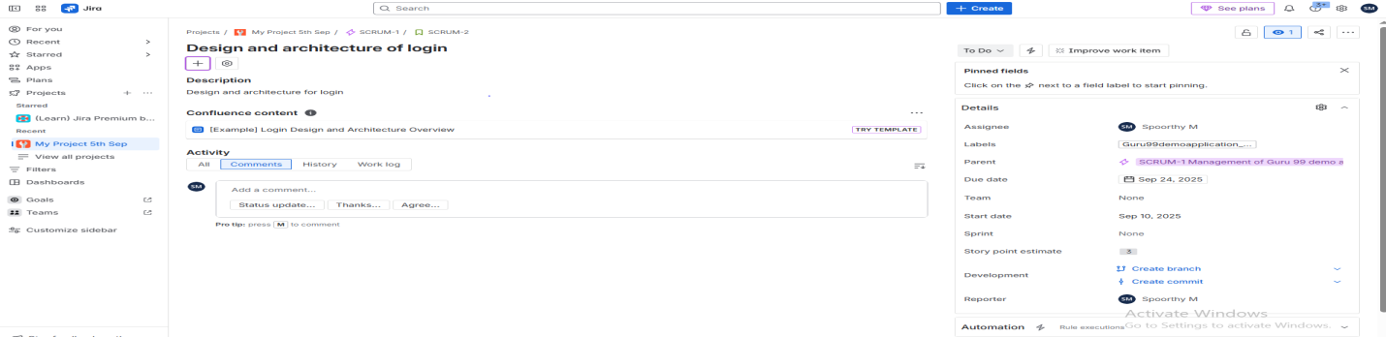  
Login –** Development of login

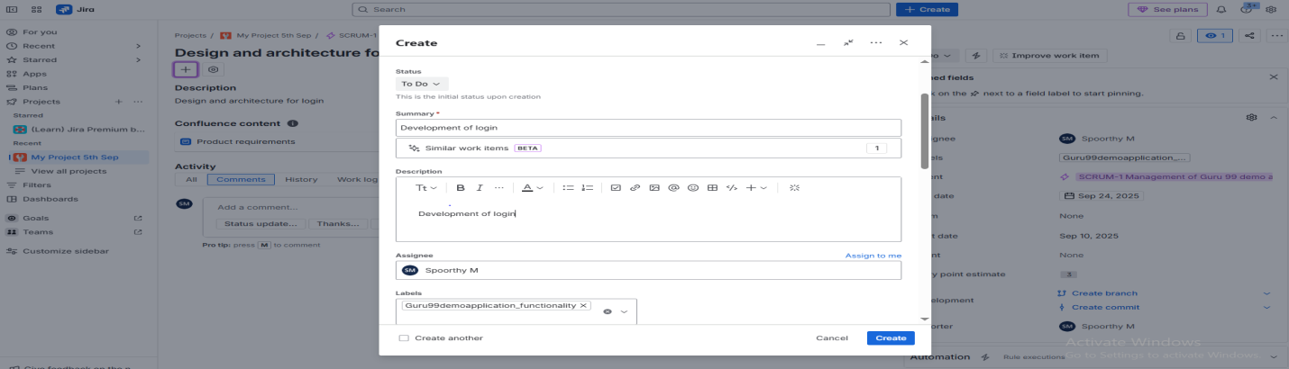

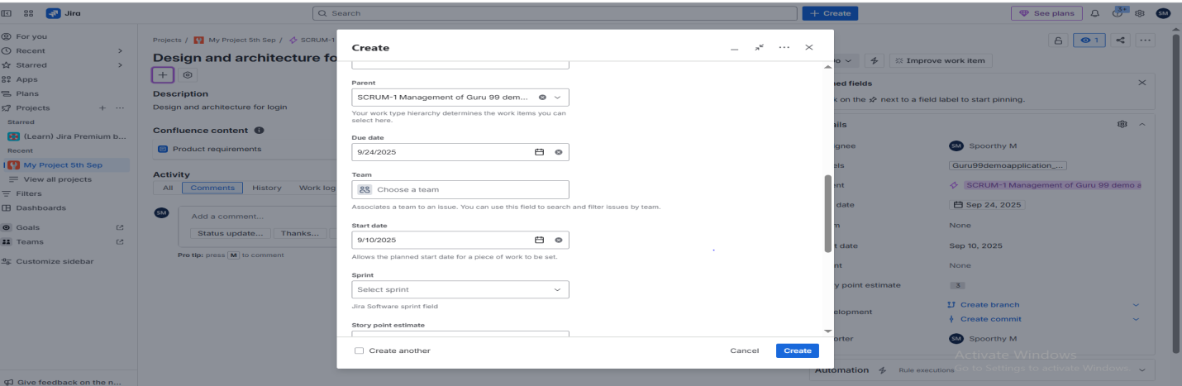

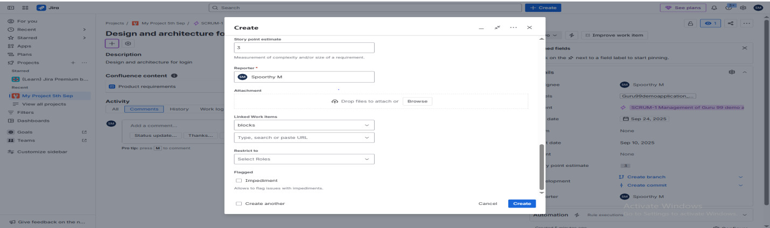

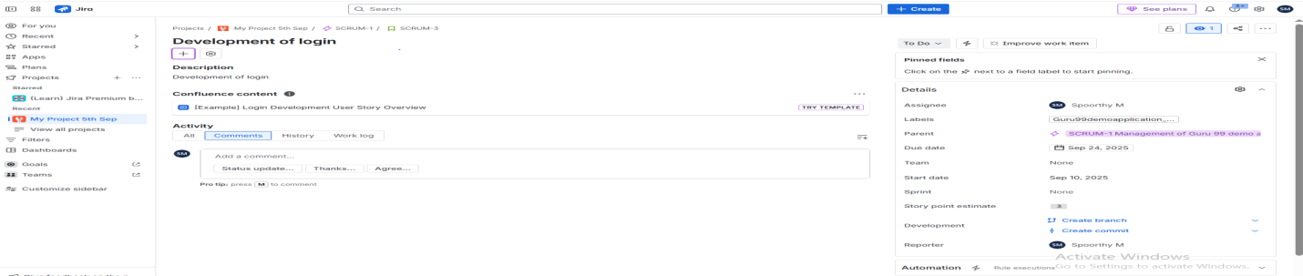  
**Login –** Subtask of Login  
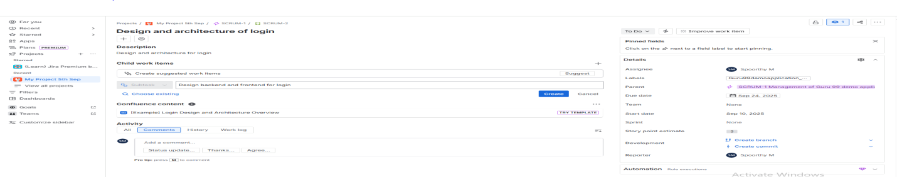

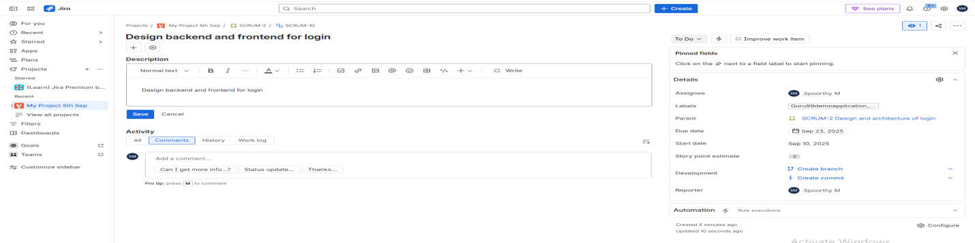

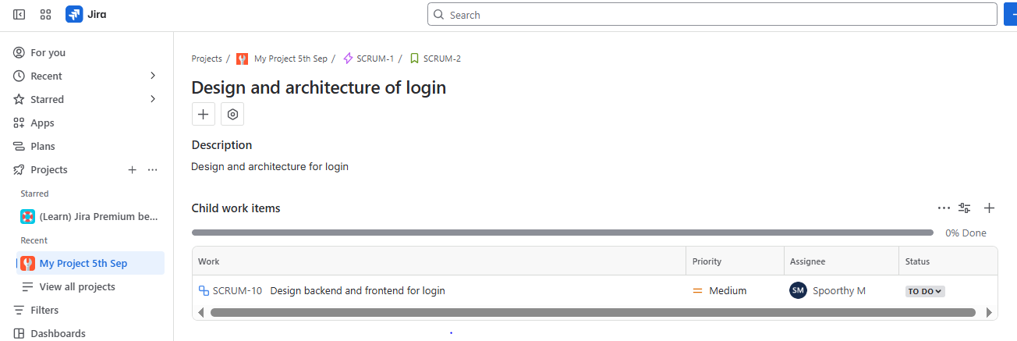  
**Login –** Subtask of Login  
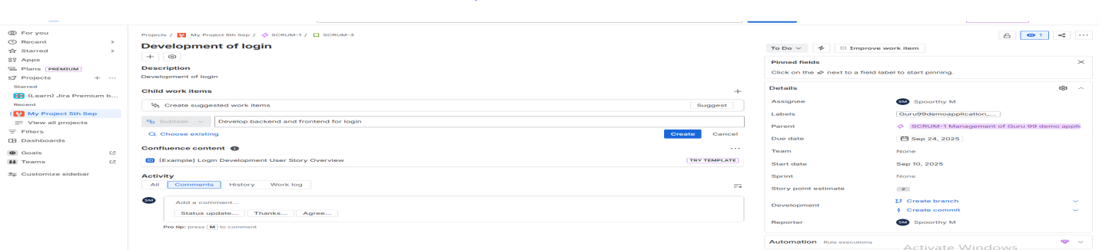 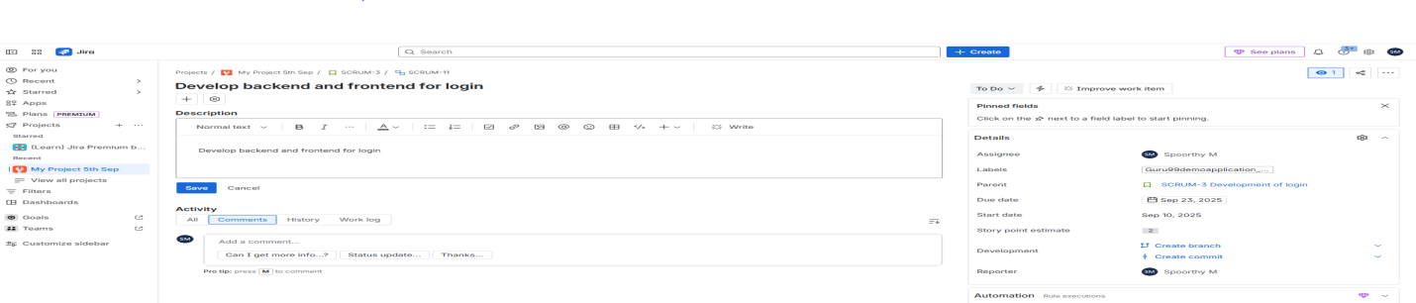 **Create Customer –** Design and Architecture of create customer  
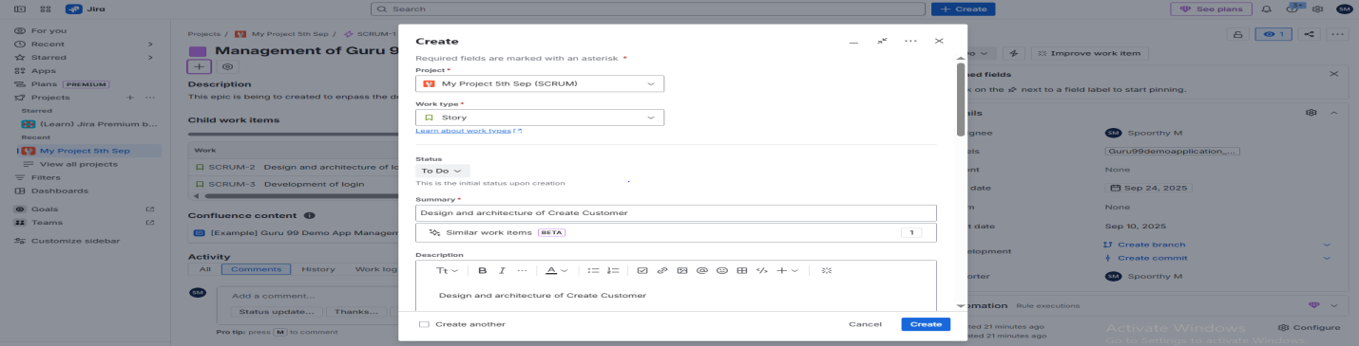

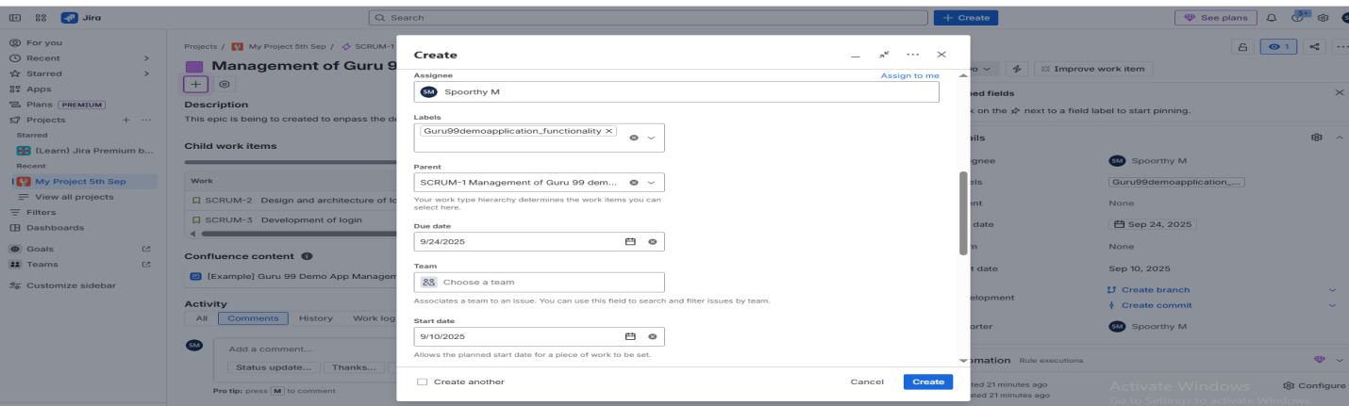

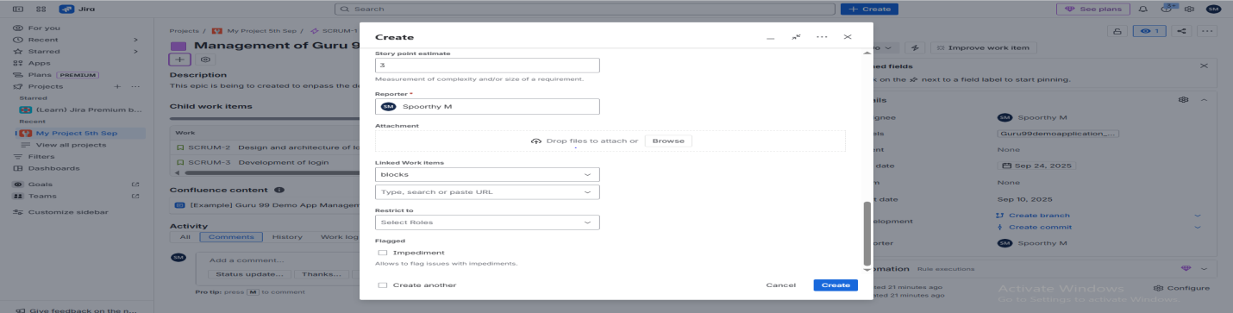

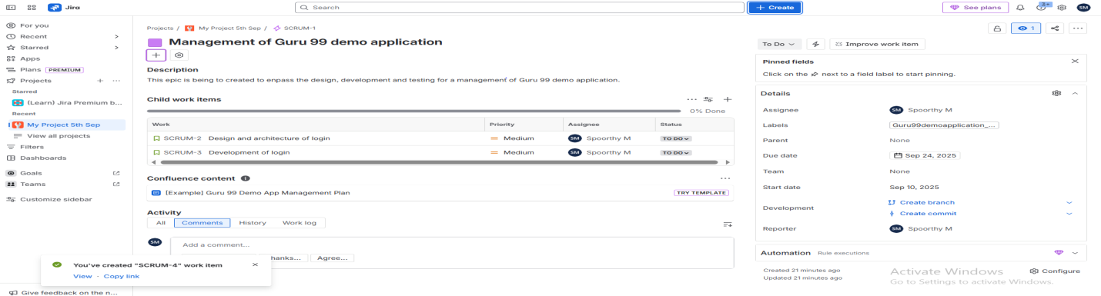

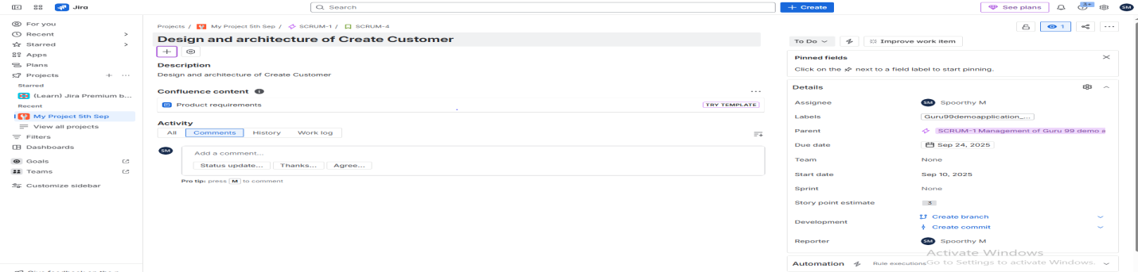 **Create Customer –** Subtask of create customer  
  
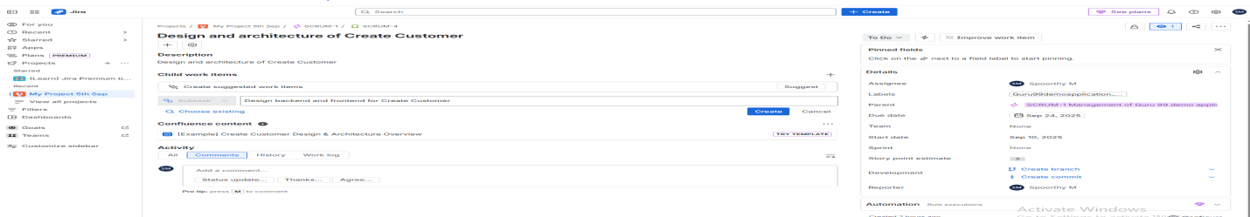

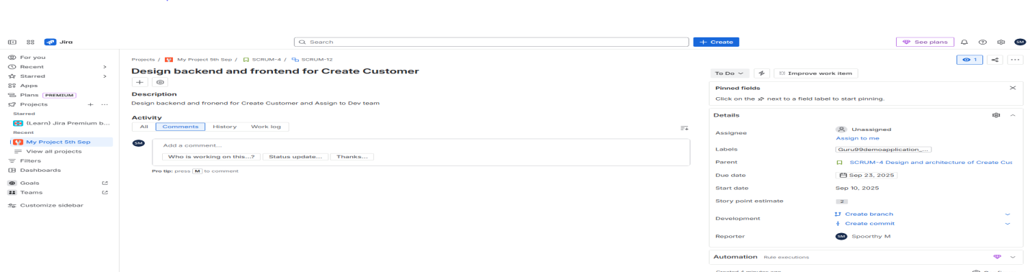

**Create Customer –** Development of create customer

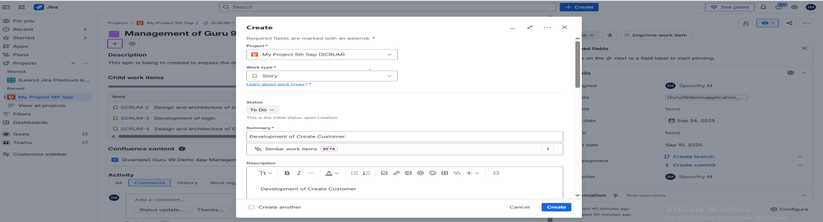

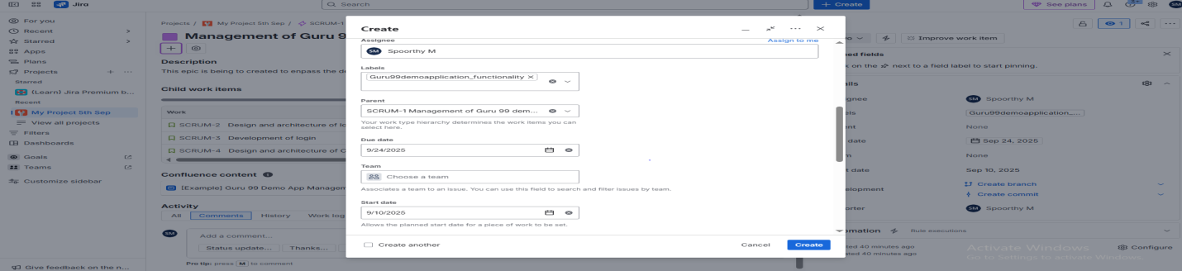

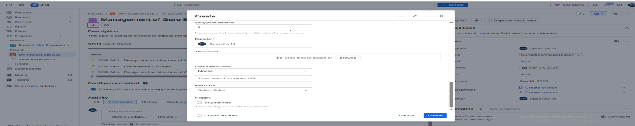

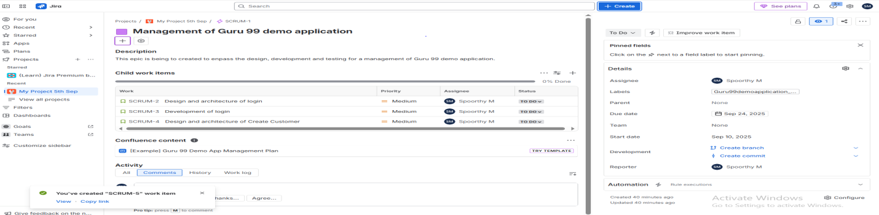

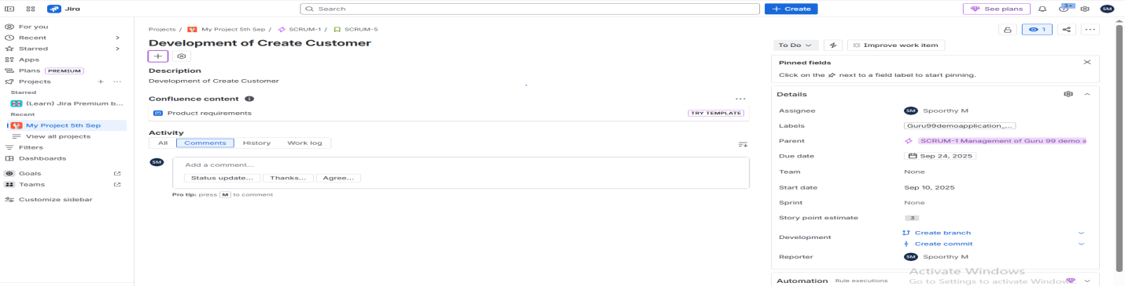 **Create Customer -** Subtask of Create Customer

**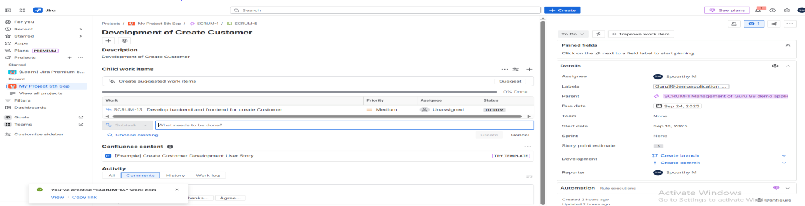 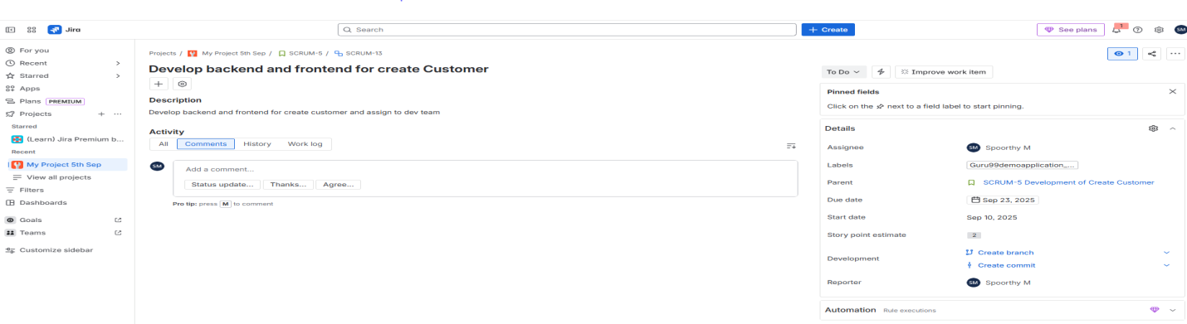  
Edit Customer –** Design and Architecture of Edit customer  
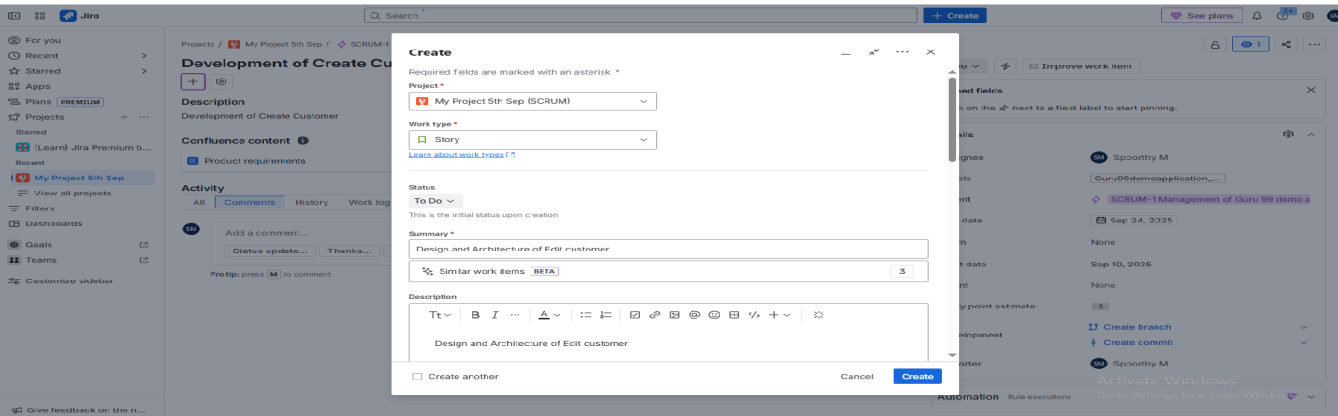

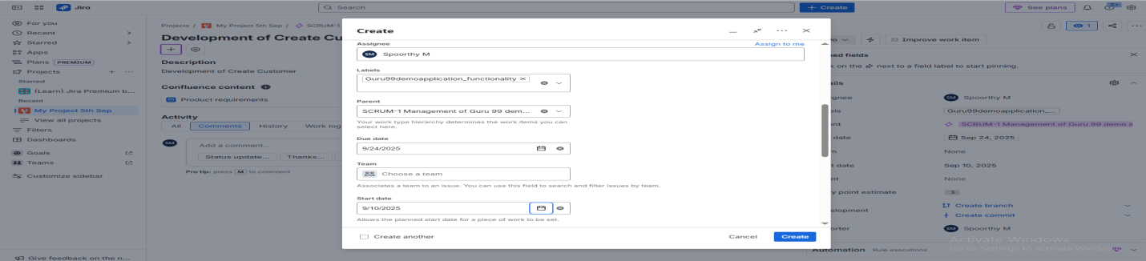

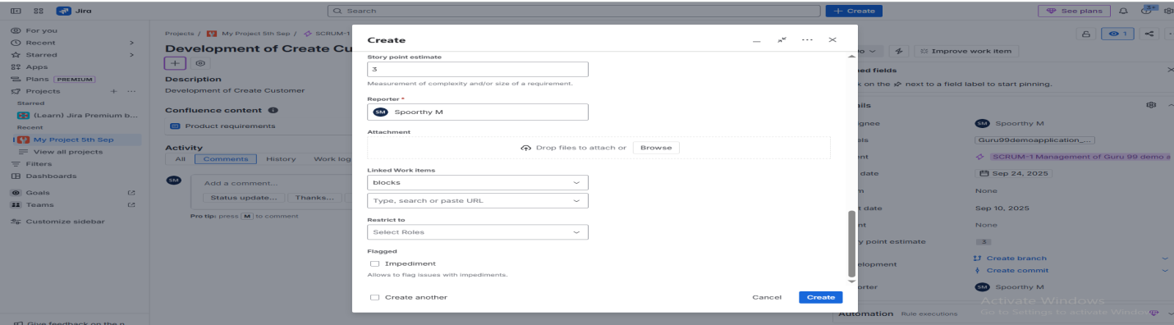

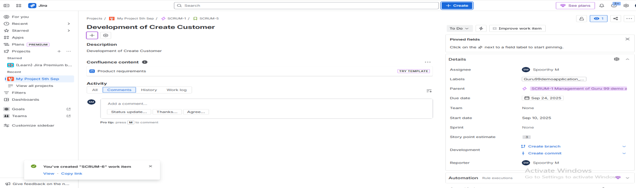

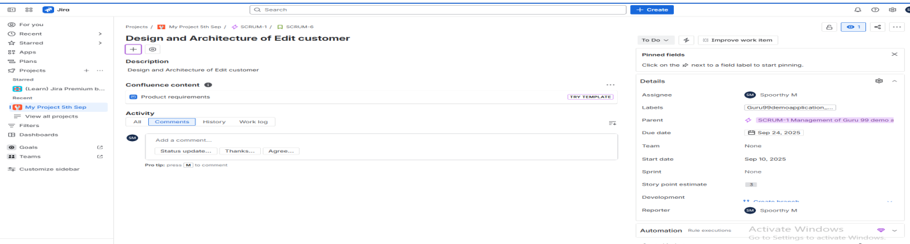 **Edit Customer –** Subtask of Edit customer  
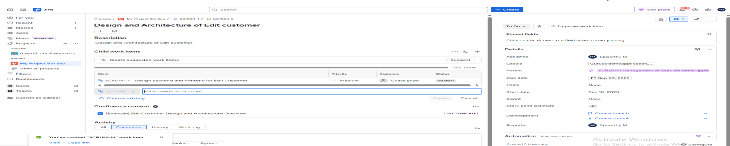

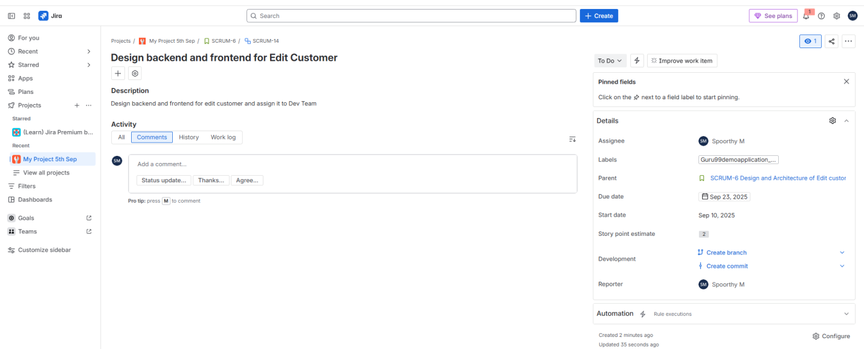  
**Edit Customer –** Development of Edit customer

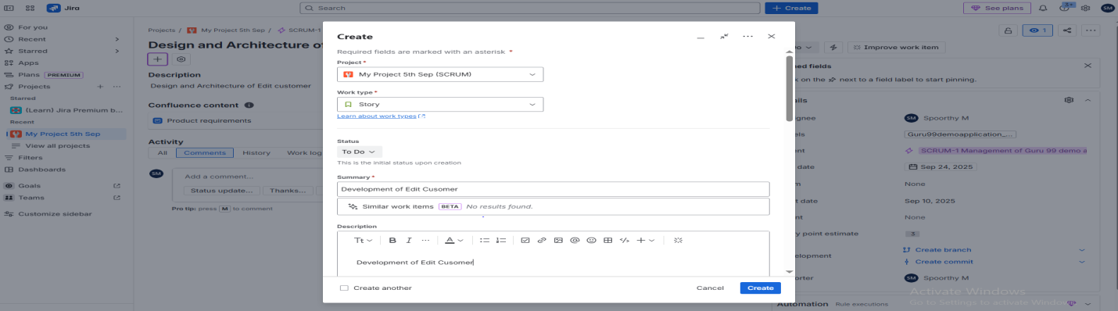

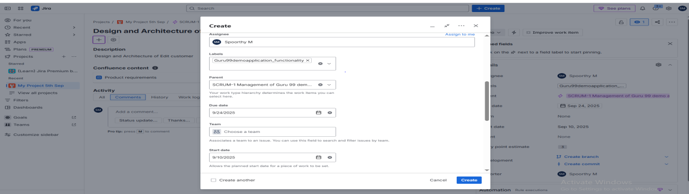

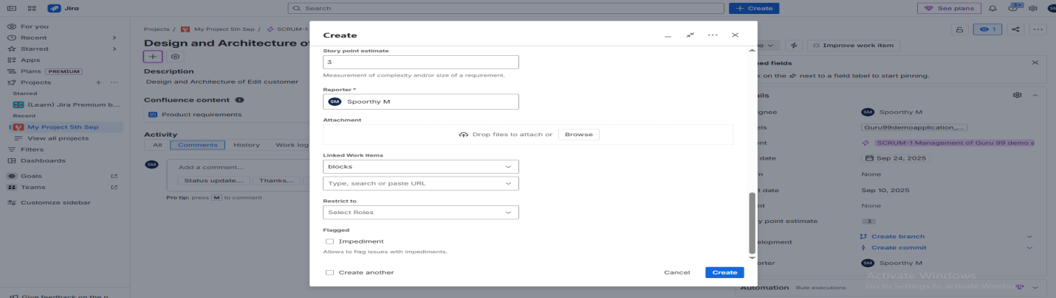

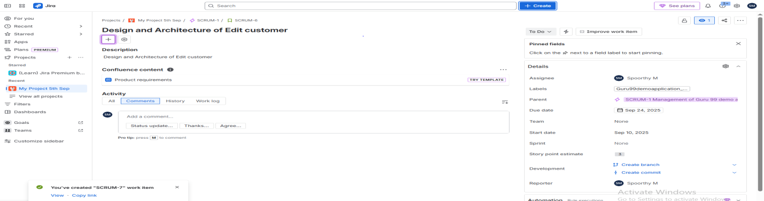

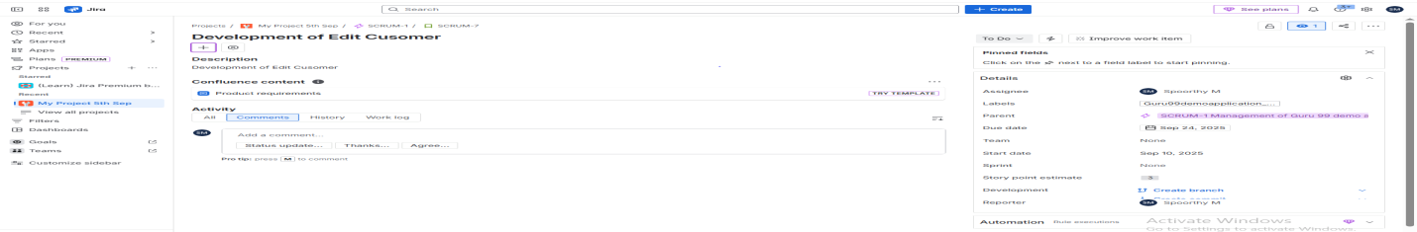

**Edit Customer –** Subtask for Edit Customer

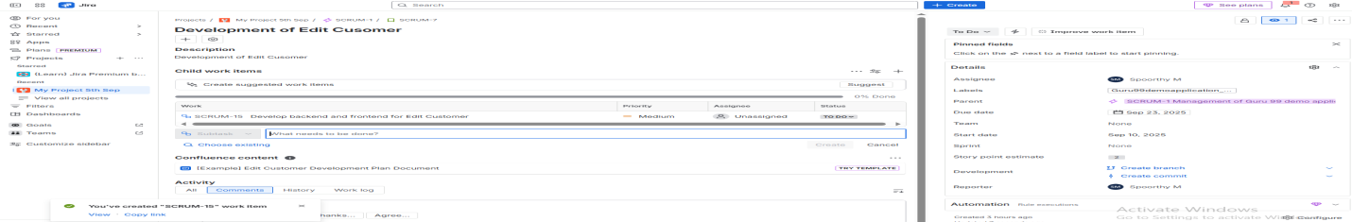

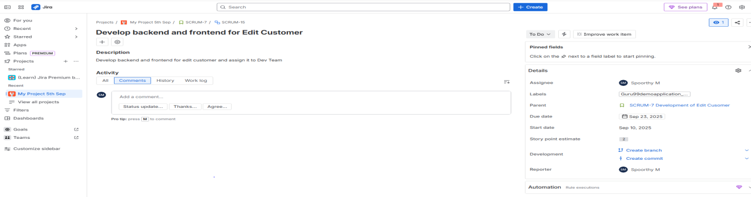

**Delete Customer –** Design and architecture of Delete Customer

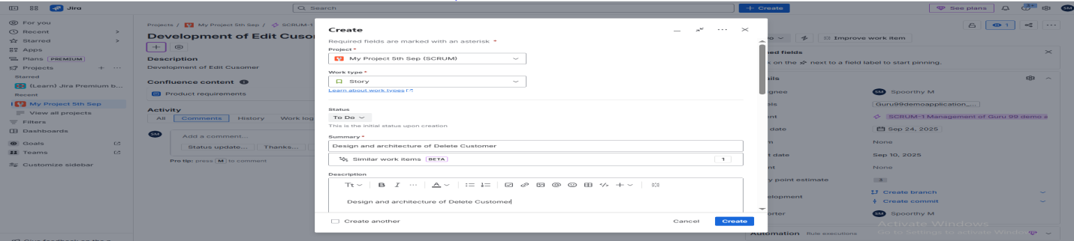

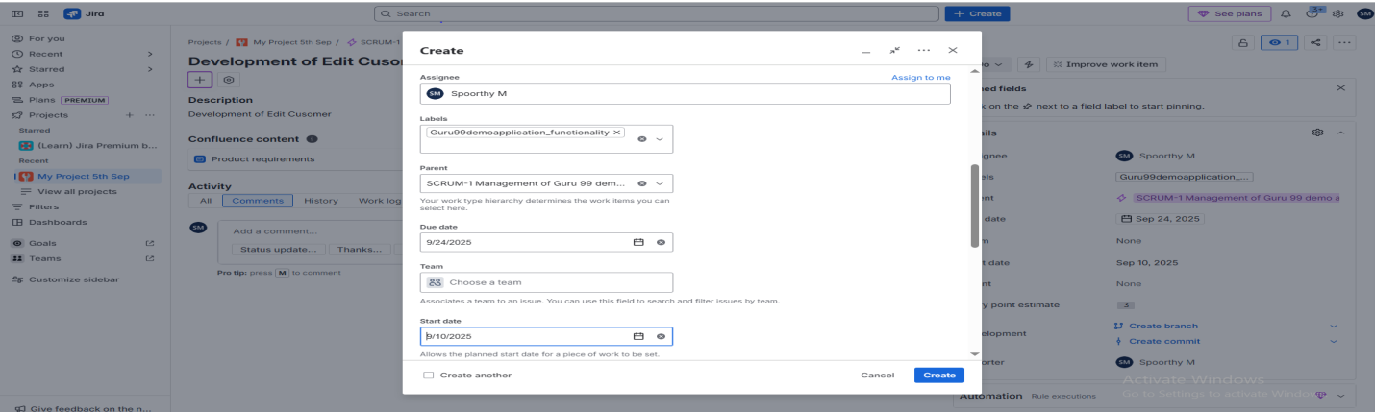

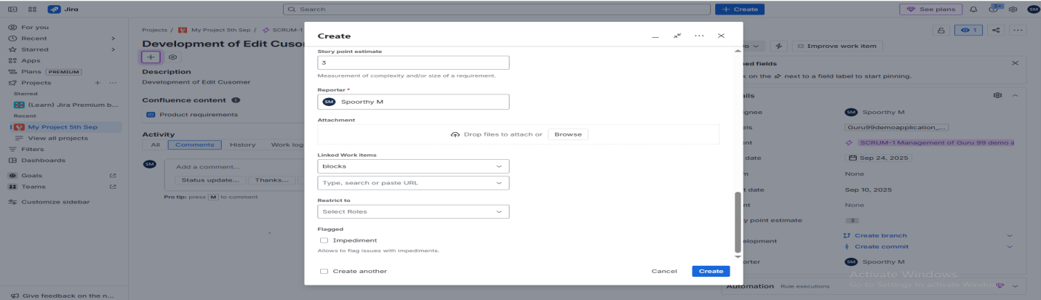  
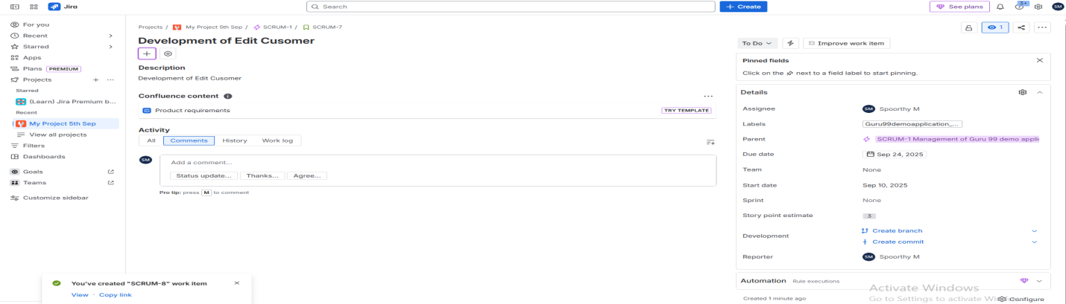

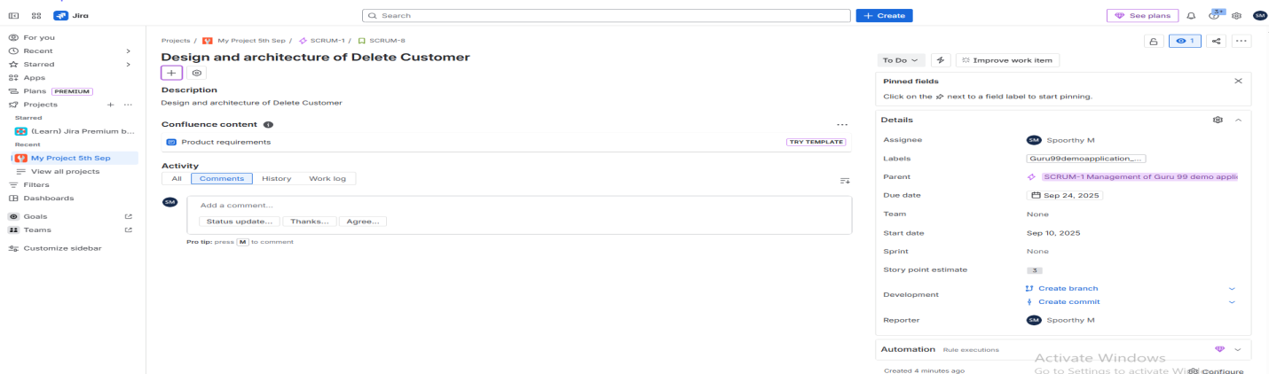

**Delete Customer –** Subtask of Delete Customer

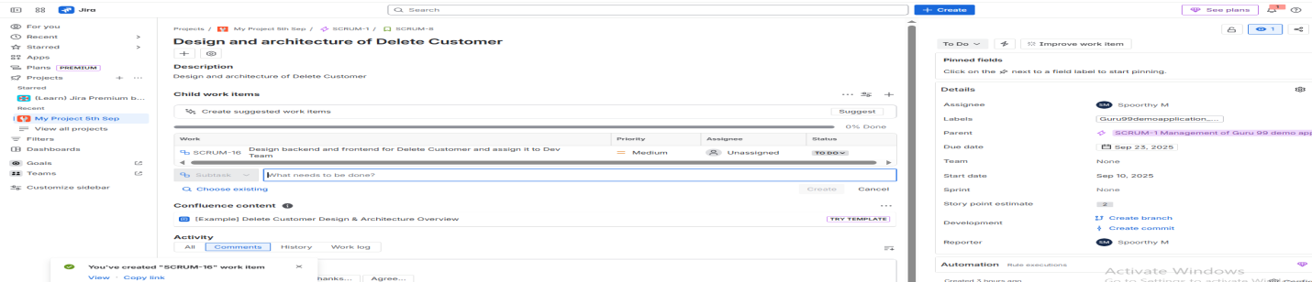

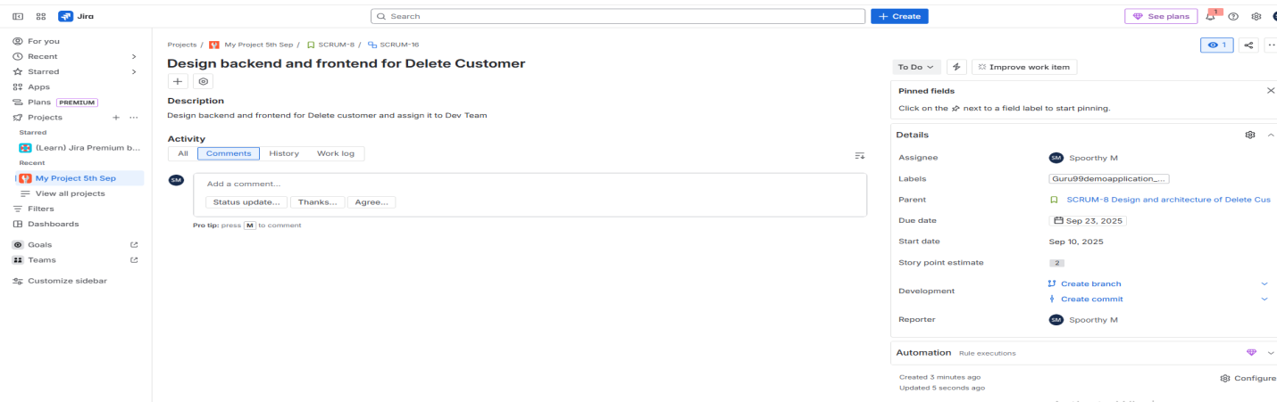

**Delete Customer –** Development of Delete Customer

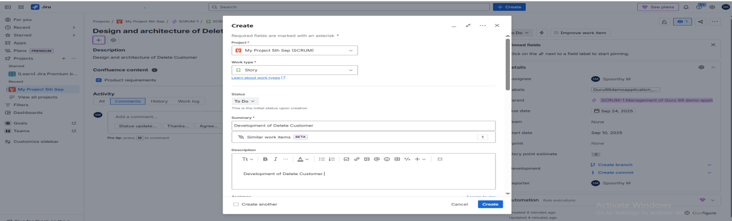

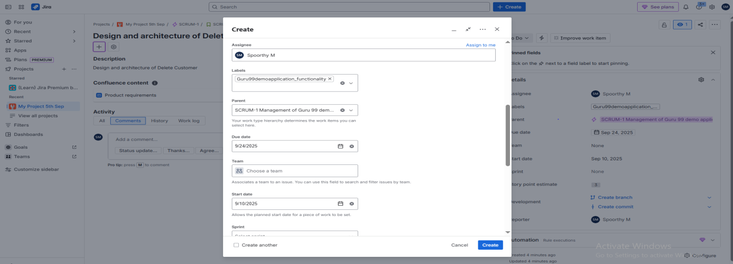

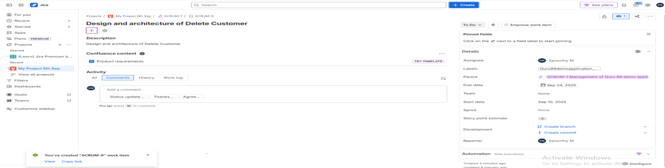

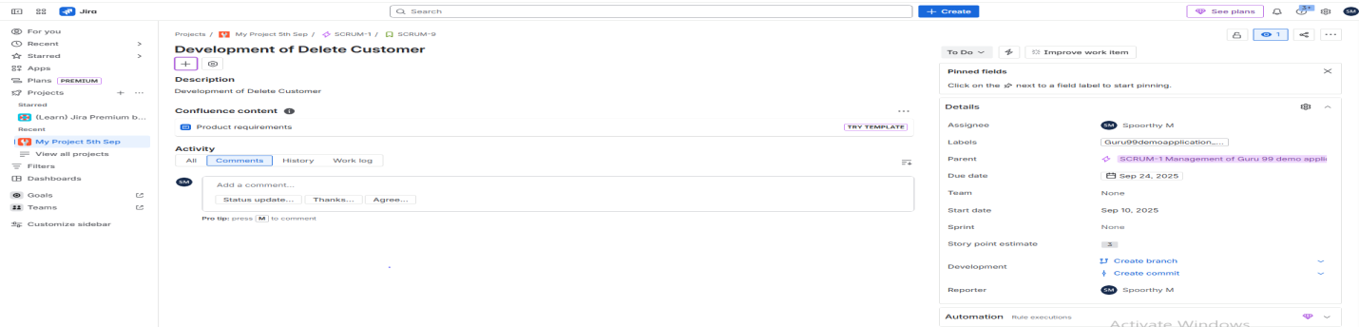

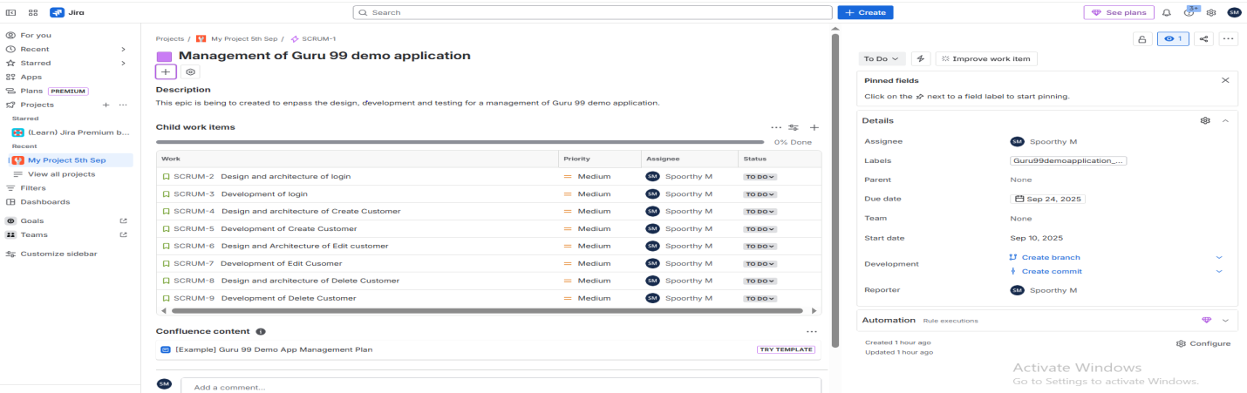

**Delete Customer –** Subtask of Delete Customer

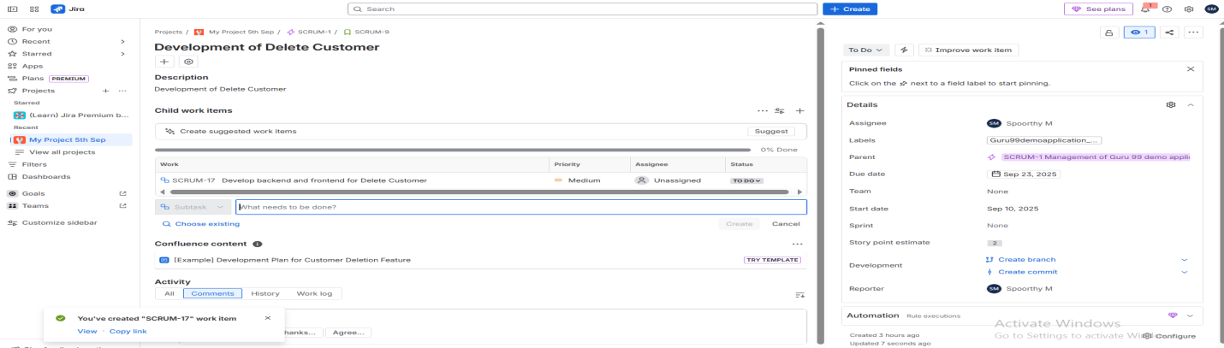

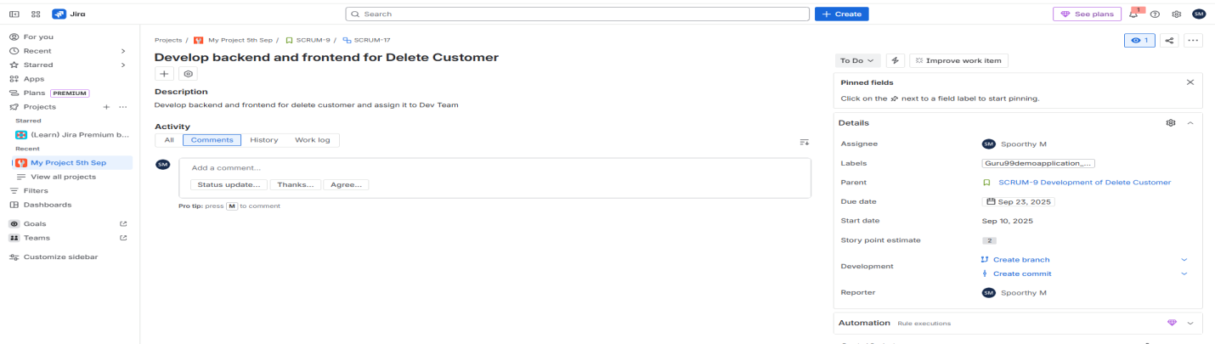

Login Test Cases

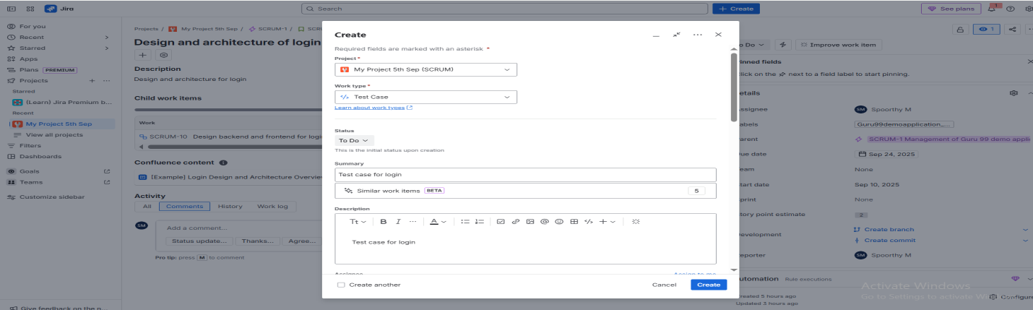

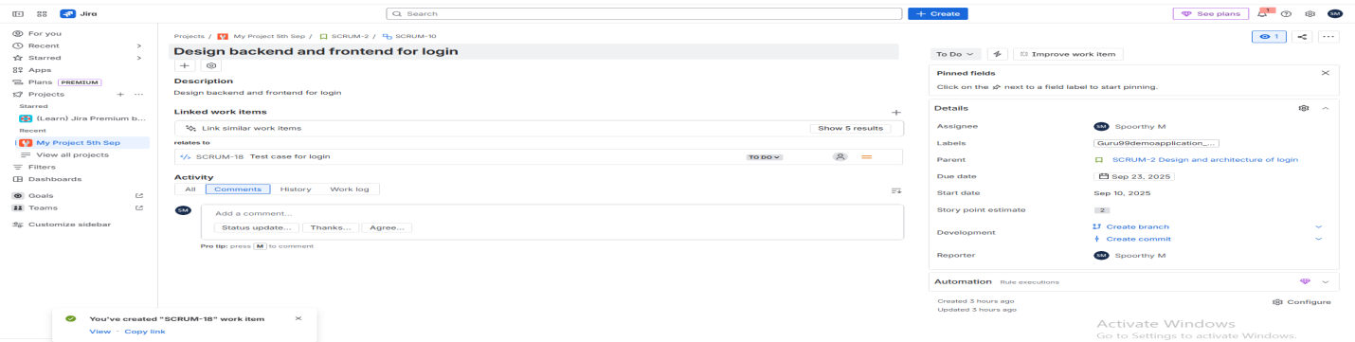

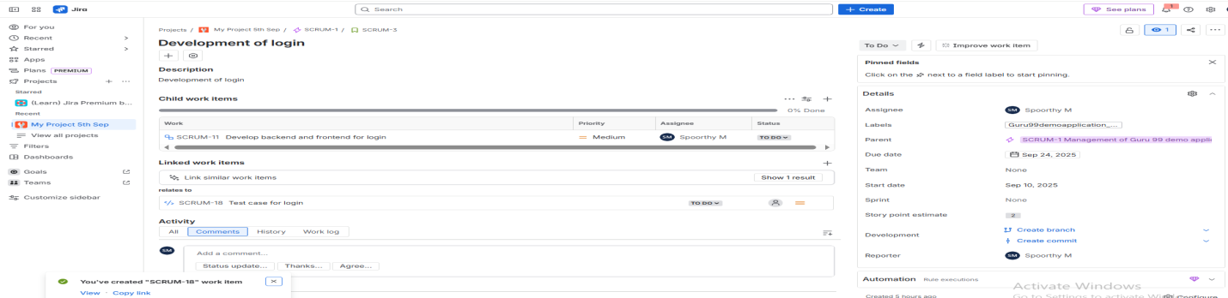  
  
Test case for Create Customer

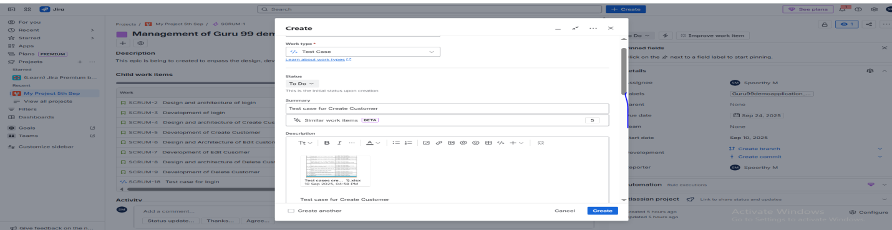

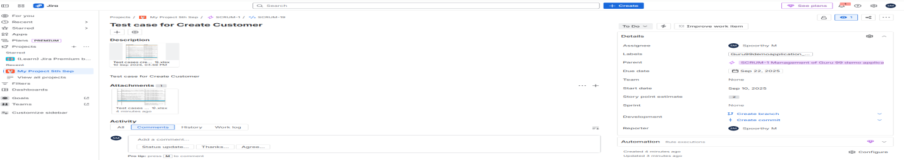

Test case for Edit Customer

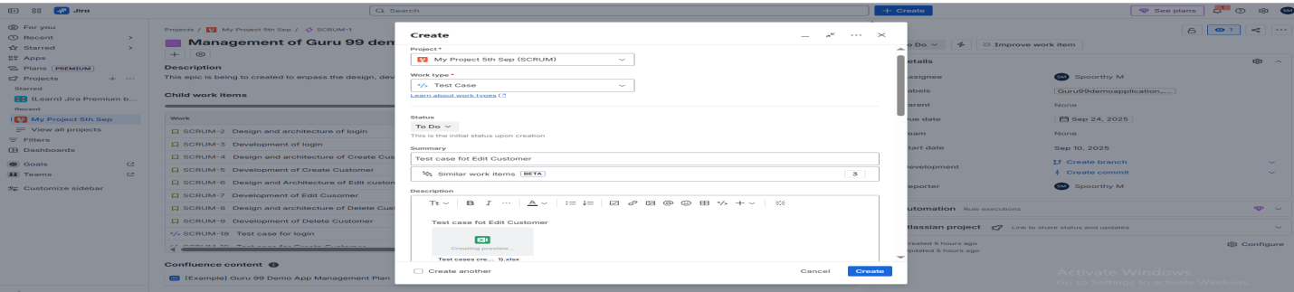

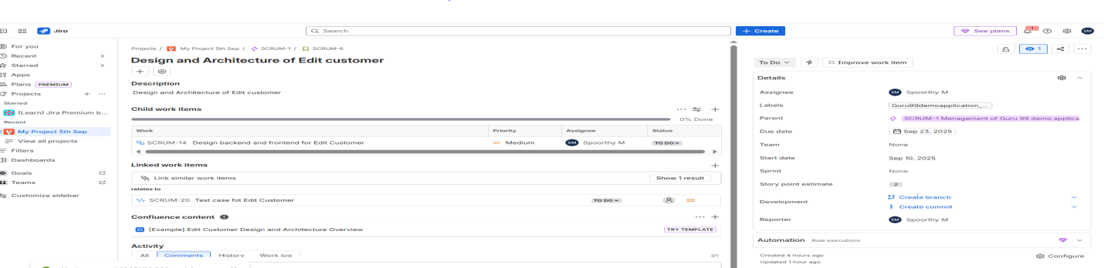  
Test case for Delete Customer

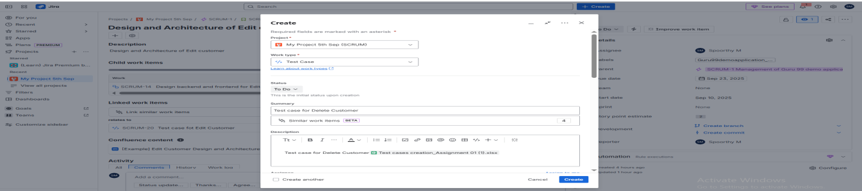

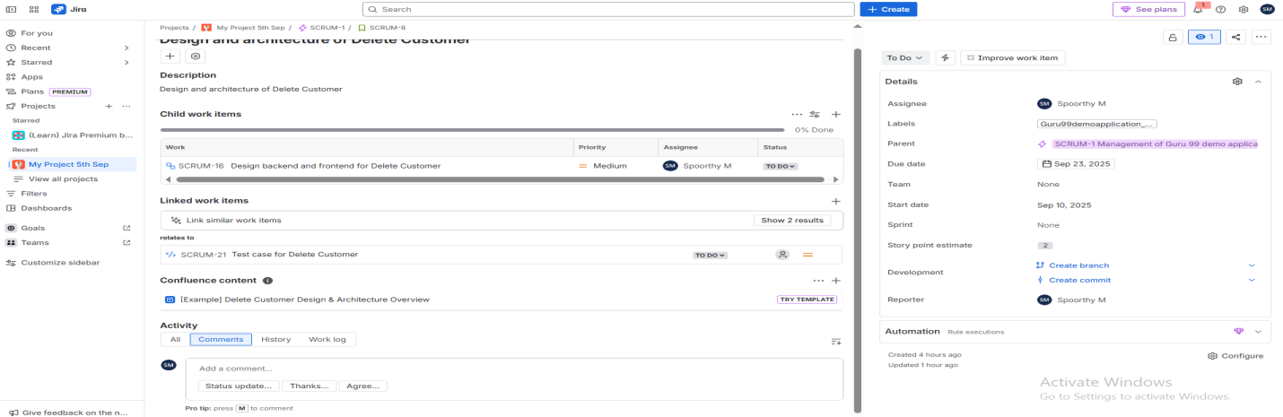

Backlog  
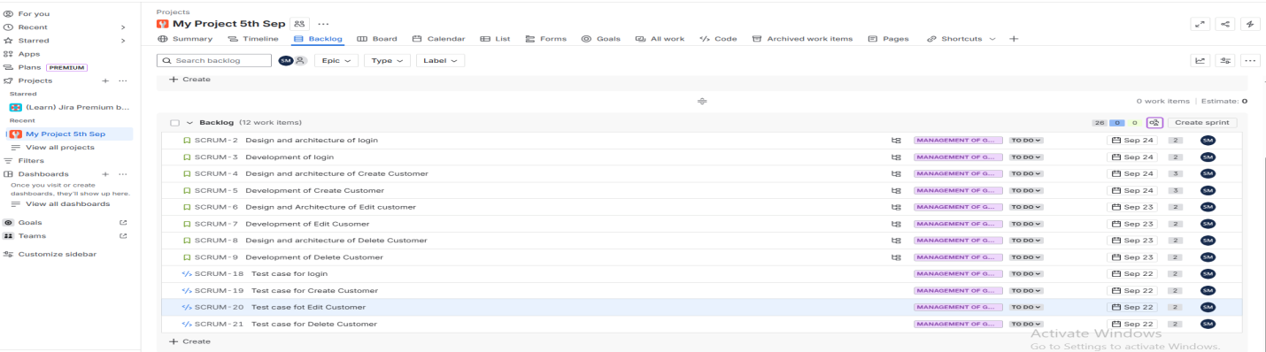Start Sprint  
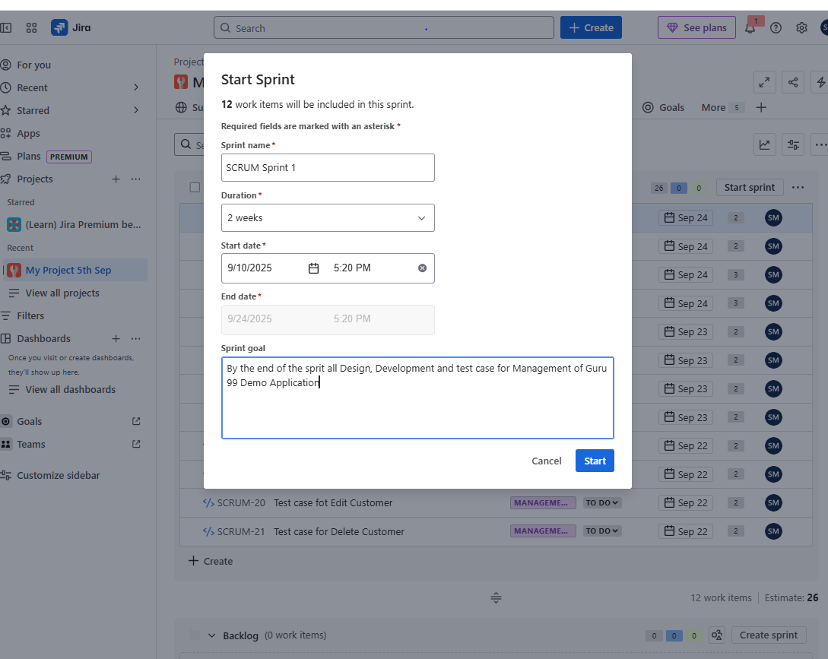

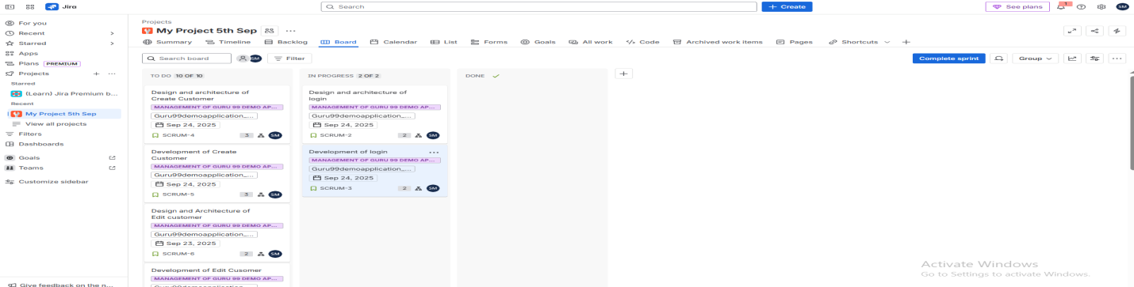  
Scrum Sprint Completed

